MAYOR
Robert V. Wheeler
CITY MANAGER
Gerald C. Smith, Sr.

COMMISSIONERS
Emma Albright
Georgana Kicinski
Del Mims
Ed Mims
Edward Gleason

CITY OF CREEDMOOR
P.O. Box 765
111 Masonic Street
Creedmoor, NC 27522
www.cityofcreedmoor.org
(919) 528-3332
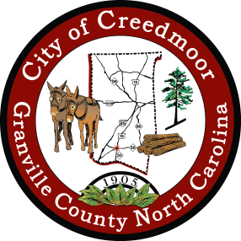

LEGAL NOTICE
SPECIAL CALLED MEETING AND REMOTE MEETING NOTICE

The Creedmoor Board of Commissioners will hold a Special Meeting on Friday, May 27, 2022 at 10 a.m.

The meeting will consist of a closed session pursuant to NCGS 143-318.11(A)(6) on a personnel matter.

To access the meeting by utilizing Zoom conference call, register using the link included below.

Register in Advance for Zoom Meeting: https://us02web.zoom.us/meeting/register/tZMpd-qprjMpG9QIAh2aNirXINV8z-h1sEW1

After registering, you will receive a confirmation email containing information about joining the meeting.

