CITY OF CREEDMOOR
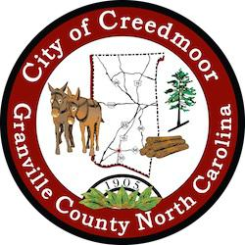

BOARD OF COMMISSIONERS
BOC - WORK SESSION
JUNE 27, 2022
6:00 PM

- CALL TO ORDER AND INVOCATION | Commissioner Kicinski

- PLEDGE OF ALLEGIANCE | Commissioner Gleason

- ROLL CALL

- APPROVAL OF AGENDA

- DISCUSSION ITEMS

5.a FY 23 PROPOSED BUDGET

  - Public Hearing
  - Adoption of Budget Ordinance 2022-x-xx

5.b IAIA Agreement | Acting City Manager Michael S. Frangos

5.c DEI Student Applicant Ash Mangum

5.d Veterans Memorial | Commissioner Mims

5.e Creedmoor Music Festival | Angie Perry

5.f Hester Road Property Update | Commissioner Mims

5.g Update on 109 Park Ave. | Commissioner Way

5.h Kerr-Tar Liaison

- ADJOURNMENT

1

