CITY OF CREEDMOOR
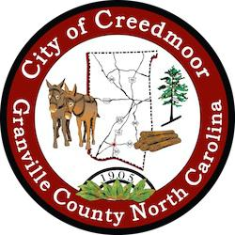

BOARD OF COMMISSIONERS
BOC - REGULAR SESSION
JULY 5, 2022
6:00 PM

- CALL TO ORDER AND INVOCATION | Mayor Pro Tem Albright

- PLEDGE OF ALLEGIANCE | Commissioner Mims

- ROLL CALL

- APPROVAL OF AGENDA

- CONSENT AGENDA

5.a Approval of Minutes:

May 27, 2022 BOC Special Session, June 02, 2022 BOC Budget Meeting, June 07, 2022 BOC Meeting

5.b NPDES Stormwater Permit Summary | Acting City Manager Michael S. Frangos

- REQUEST TO ADDRESS THE BOARD 6.a CPRC Application Kaitlyn King
- PUBLIC COMMENT

- OLD BUSINESS

8.a CVFD Agreement

8.b Sale of Surplus City Property: 109 Park Avenue and 1129 Hester Road

- NEW BUSINESS

9.a NCDOT Landscape Agreement (R-5707L)

9.b Authorization to Proceed with GPRS

- DISCUSSION ITEMS

10.a DEI/GARE - Racial Equity Toolkit | Mayor Pro Tem Albright Zoom discussion

10.b Wooten Assessment of Creedmoor Community Center Retaining Wall

- CITY MANAGER'S REPORT

1

11.a Community Development Manager's Report

11.b CPD Manager's Report

11.c Public Works Report

11.d Recreation Manager's Report

- SGWASA REPORT

- COMMISSIONER REPORTS

- MAYOR'S REPORT

- CLOSED SESSION

15.a NCGS 143-318.11(a)(3)and (6) Personnel and Attorney Client Privilege | Commissioner Kicinski

- ADJOURNMENT

2

