CITY OF CREEDMOOR
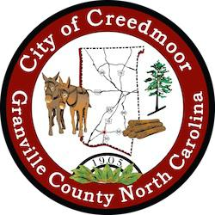

BOARD OF COMMISSIONERS
BOC - WORK SESSION
JULY 18, 2022
6:00 PM

- CALL TO ORDER AND INVOCATION | Commissioner Way

- PLEDGE OF ALLEGIANCE | Commissioner Gleason

- ROLL CALL

- APPROVAL OF AGENDA

- DISCUSSION ITEMS

5.a Retail Strategies | Matt Jaeger & Scott VonCannon

5.b Creedmoor Music Festival | Christopher Horrigan

5.c Telware Update | Commissioner Kicinski

5.d Police Chief Recruitment | Keith King

- ADJOURNMENT

1

