CITY OF CREEDMOOR
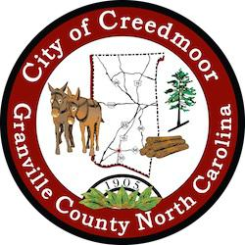
PLANNING BOARD
PLANNING BOARD MEETING
AUGUST 11, 2022

7:00 PM

CALL TO ORDER

- RECOGNITION OF QUORUM

- APPROVAL OF AGENDA

- APPROVAL OF MINUTES

Minutes of June 9, 2022 Planning Board

- PUBLIC COMMENT

- OLD BUSINESS

- NEW BUSINESS

Planning Board Member Vacancies

7. REPORT ON RECENT DEPARTMENT ACTIVITY

Acting City Manager/Community Development Director Michael Frangos

8. REPORTS FROM CHAIRPERSON AND MEMBERS ADJOURN

1

