CITY OF CREEDMOOR
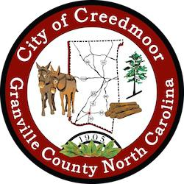

BOARD OF COMMISSIONERS
BOC - WORK SESSION
AUGUST 15, 2022
6:00 PM

- CALL TO ORDER AND INVOCATION | Commissioner Gleason

- PLEDGE OF ALLEGIANCE | Mayor Pro Tem Albright

- ROLL CALL

- APPROVAL OF AGENDA

- DISCUSSION ITEMS

5.a Request for Harris Park Memorial Monument | P. 2-6

5.b Public Facilities Cleaning Services | Michael Frangos | P. 7-33

5.c Stormwater Repair Projects | John Boyer | P. 34-36

5.d Creedmoor Community Center Retaining Wall Options | John Boyer | P. 37-39

5.e Financial Status Update | Candy Bowman | P. 40-43

5.f City Manager Hiring Criteria | P. 44-52

5.g Closed Session // NC GS 143-318.11 (a) (6) Personnel

- ADJOURNMENT

1

