CITY OF CREEDMOOR
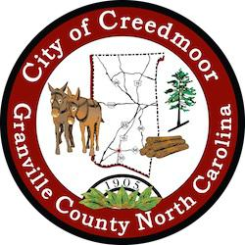

BOARD OF COMMISSIONERS
BOC - WORK SESSION
SEPTEMBER 19, 2022
6:00 PM

- CALL TO ORDER AND INVOCATION | Commissioner Kicinski

- PLEDGE OF ALLEGIANCE | Commissioner Mims

- ROLL CALL

- APPROVAL OF AGENDA

- DISCUSSION ITEMS

5.a Closed Session // NC GS 143-318.11 (a) (6) Personnel

5.b DEI Zoom access for public | Mayor Pro Tem Albright

5.c Update on City Hall Expansion Project | Little Diversified Architecture

5.d Creedmoor Hydraulic Study Final Report | SGWASA

5.e Discussion PFOA's PFO's testing | SGWASA

5.f Stormwater Drainage Projects Update | John Boyer

5.g Paychex Update

5.h Police In-car and Body Worn Contract /Vendor Change | Keith King

5.i Veteran's Day Breakfast | Commissioner Kicinski

5.j Ads for 109 Park Avenue - The Herald Sun and The News and Observer

- ADJOURNMENT

1

