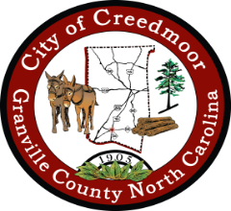
CITY OF CREEDMOOR
DEI ADVISORY BOARD
August 24, 2022
6:00 PM

- CALL TO ORDER AND INVOCATION
- PLEDGE OF ALLEGIANCE
- APPROVAL OF AGENDA
- PUBLIC COMMENT
- DISCUSSION ITEMS
  - CoC DEI AB/GCHRC Leadership Summit
  - CoC DEI AB Constituent Town Hall
  - CoC DEI AB Constituent Survey
  - Tool for BOC
  - Schedule for Music Festival
  - Survey questions for the festival and town hall
  - Town hall final agenda and flyers

- OTHER BUSINESS
- CoC DEI AB Member Recruiting

- ADJOURNMENT

