CITY OF CREEDMOOR
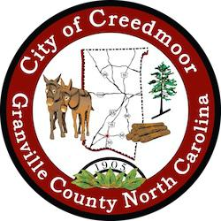
PLANNING BOARD
PLANNING BOARD MEETING
OCTOBER 13, 2022

7:00 PM

CALL TO ORDER

- RECOGNITION OF QUORUM

- APPROVAL OF AGENDA

- APPROVAL OF MINUTES Minutes from September 8, 2022
- PUBLIC COMMENT

- OLD BUSINESS

Discussion of Joint Planning Board & Board of Adjustment

6. NEW BUSINESS

Discussion of Water and Wastewater Allocation Policy

- REPORT ON RECENT DEPARTMENT ACTIVITY

- REPORTS FROM CHAIRPERSON AND MEMBERS

ADJOURN

1

