CITY OF CREEDMOOR
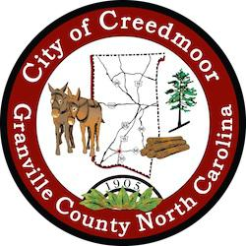
BOARD OF COMMISSIONERS
BOC - WORK SESSION
NOVEMBER 21, 2022
6:00 PM

- CALL TO ORDER AND INVOCATION | Commissioner Way

- PLEDGE OF ALLEGIANCE | Commissioner Gleason

- ROLL CALL

- APPROVAL OF AGENDA

- DISCUSSION ITEMS

5.a CVFD Presentation | Assistant Chief Matt Foley

5.b Community Center and Recreation Update | C. Horrigan, Recreation Director

5.c Recreation Department Fee Schedule Updates | C. Horrigan, Recreation Director

5.d Fire False Alarm Ordinance | Kevin Hornik

5.e City of Creedmoor Social Media Policy | Kevin Hornik

5.f Commissioner's Responsibilities and Obligations as Liaison's to Other Committees, Boards, etc. | Kevin Hornik

5.g DEI Discussion | Mayor Wheeler

- FINANCE REPORT

6.a 1. Quarterly Financial Update [July, August, Sept 2022] -2. Budget Amendment 4 FY 23 | Candy Bowman

- CLOSED SESSION

7.a Closed Session NC GS 143-318.11(a)(3)(1) Attorney Client Privilege [Cates matter] and Personnel

- ADJOURNMENT

1

