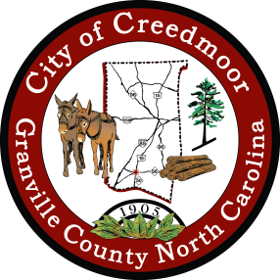
City of Creedmoor
Board Of Adjustment
Regular Meeting Agenda
November 7, 2022
7 pm

Call To Order

- Recognition of Quorum

- Approval of Agenda

- Review And Approval Of Minutes From May 2, 2022

- Training

- Report on Recent Department Activity

- Reports from Chairperson and Members

Adjourn

