CITY OF CREEDMOOR
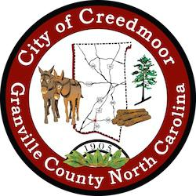
BOARD OF COMMISSIONERS
BOC - WORK SESSION
FEBRUARY 21, 2023
6:00 PM

- CALL TO ORDER AND INVOCATION

- PLEDGE OF ALLEGIANCE

- ROLL CALL

- APPROVAL OF AGENDA

- DISCUSSION ITEMS

5.a Introduction of Carla Hobbs as Interim Finance Director | City Manager

5.b Introduction of Carl A. Barclay, MPA, PE as new City Engineer | Michael Frangos

5.c Proclamation for Shawnti Jackson | Mayor Wheeler

5.d Music Festival Rules Regarding Political Tents and Service Animals| Commissioner Kicinski and City Attorney Kevin Hornik

5.e 2023 Creedmoor Music Festival Committee Update | Christopher Horrigan

5.f Multi-Sports Events Plaza Construction Bid Results | Christopher Horrigan

5.g VSO (Veterans Services Org.) sharing office in City Hall | City Manager

5.h GoGov Software | Commissioner Gleason

5.i Mule Town | Michael Frangos

5.j Discussion on Increased Visiability and Safety of Public Works Vehicles | Commissioner Way

5.k Stormwater Service Contracts | Michael Frangos

- CLOSED SESSION

6.a Closed Session Per § 143-318.11.a(5) |

- ADJOURNMENT

1

