MAYOR
Robert V. Wheeler
CITY MANAGER
Michael O. Turner

COMMISSIONERS
Emma Albright
Edward Gleason
Georgana Kicinski
Robert Way
Archer Wilkins

CITY OF CREEDMOOR
P.O. Box 765
111 Masonic Street
Creedmoor, NC 27522
www.cityofcreedmoor.org
(919) 528-3332
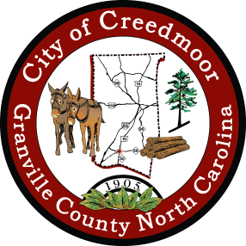

LEGAL NOTICE

CANCELLED -
CITY OF CREEDMOOR
PLANNING BOARD MEETING

The City of Creedmoor Planning Board meeting
that was scheduled to be held on June 8, 2023 at 7 p.m. in the
Boardroom at City Hall, 111 Masonic Street, Creedmoor, NC.
has been
Cancelled.

*Any questions should be directed to Barbara Rouse, City Clerk to: brouse@cityofcreedmoor.org

