MAYOR
Robert V. Wheeler
CITY MANAGER
Michael O. Turner

COMMISSIONERS
Emma Albright
Edward Gleason
Georgana Kicinski
Robert Way
Archer Wilkins

CITY OF CREEDMOOR
P.O. Box 765
111 Masonic Street
Creedmoor, NC 27522
www.cityofcreedmoor.org
(919) 528-3332
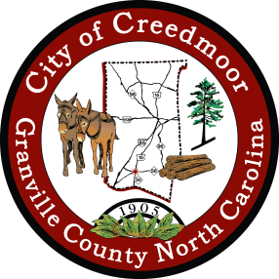

LEGAL NOTICE
CITY OF CREEDMOOR
DEI MEETING

Meeting Notice

Please take notice that the
City of Creedmoor DEI Advisory Board Meeting
will be held on
Wednesday, July 26th , 2023 at 6 p.m.
at the Creedmoor Community Center
116 Douglas Drive,
Creedmoor, NC

