CITY OF CREEDMOOR
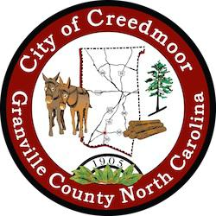
BOARD OF COMMISSIONERS
BOC - WORK SESSION
JULY 17, 2023
6:00 PM

- CALL TO ORDER AND INVOCATION

- PLEDGE OF ALLEGIANCE

- ROLL CALL

- APPROVAL OF AGENDA

- DISCUSSION ITEMS

5.a Proclamation - Parks and Recreation Month in Creedmoor | Mayor Wheeler

5.b Application for Planning Board ETJ member Chad Abbott | Barbara Rouse, City Clerk

5.c Presentation by the Upper Neuse River Basin Association (UNRBA) | Forrest Westfall, Executive Director

5.d Mr. Randy Lanou representing Mule Town Depot request to address the Board | Randy Lanou

5.e NC Park and Recreation Conference |and NCRPA Diversity, Equity, & Inclusion Carolinas

Joint Conference Scholarship | Christopher Horrigan, Recreation Department Director

5.f Granville County TDA Grants (2) Approval | Christopher Horrigan, Recreation Department Director

5.g 2023 Granville County Mini-Grant | Christopher Horrigan, Recreation Department Director

5.h Discuss offer to Purchase the Hester Road Property | Michael Turner, City Manager

5.i Ferbow Street Utility Relocation | Michael S. Frangos AICP, CZO Community Development Director

5.j Storm Water Repair Update - 2766 Clifton Avenue | Michael S. Frangos AICP, CZO Community Development Director

5.k Code Enforcement Officer Hours // Michael S. Frangos AICP, CZO Community Development Director

5.l Sidewalk Gap Projects | Carl Barclay P.E., City Engineer

5.m Legislative Housing Bills: SB 275 and HB 409 | Mayor Pro Tem Albright

1

- ADJOURNMENT

2

