CITY OF CREEDMOOR
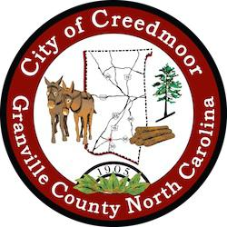
BOARD OF COMMISSIONERS
BOC - WORK SESSION
AUGUST 21, 2023
6:00 PM

- CALL TO ORDER AND INVOCATION | Mayor Wheeler and Mayor Pro Tem Albright

- PLEDGE OF ALLEGIANCE | Commissioner Kicinski

- ROLL CALL

- APPROVAL OF AGENDA

- INTRODUCTIONS, RECOGNITIONS AND PRESENTATIONS

5.a Proclamation for Pecan Hill Neighborhood 35th Annual Reunion | Mayor Robert Wheeler

- DISCUSSION ITEMS

6.a Creedmoor Volunteer Fire Department Update | Chief Fisher and Assistant Chief Foley

6.b Update on FY24 Community Center PROGRAMS, Proposed City Sponsored EVENTS and update on the Creedmoor Music Festival (CMF), | Christopher Horrigan

6.c GOGov Update | Commissioner Gleason

6.d City of Creedmoor Diversity Equity & Inclusion (DEI) Advisory Board Update | Commissioner Gleason

6.e SGWASA Water and Sewer Allocation Discussion | Michael S. Frangos AICP, CZO

6.f Discussion on Mayor's Term Limits | Kevin Hornik

6.g Second Extension of Waste Industries (GFL, Environmental) Solid Waste Collection Transportation and Disposal Agreement | Michael Turner

6.h Update on Creedmoor Veterans Organization Banners and Veterans Memorial | MPT Albright and Commissioner Wilkins

6.i Financial Summary Report | Lee Faines

- ADJOURNMENT

- CLOSED SESSION

8.a Closed Session per § 143-318.11.a (3), (6) Attorney Client Privilege and Personnel

1

