MAYOR
Robert V. Wheeler
CITY MANAGER
Michael O. Turner

COMMISSIONERS
Emma Albright
Edward Gleason
Georgana Kicinski
Robert Way
Archer Wilkins

CITY OF CREEDMOOR
P.O. Box 765
111 Masonic Street
Creedmoor, NC 27522
www.cityofcreedmoor.org
(919) 528-3332
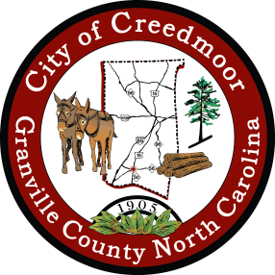

Proclamation
Honoring Commissioner Ernie M. Anderson for his Service to the City of Creedmoor

Whereas: Commissioner Ernie Anderson has spent many years serving the citizens of Creedmoor in multiple capacities and roles.

Whereas: Commissioner Ernie Anderson served his Country honorably in the U.S. Army.

Whereas: Commissioner Ernie Anderson was elected to the City of Creedmoor Board of Commissioners in November 2016 and served through December 2020. During his time on the board, he served Creedmoor as Mayor Pro Tem 2019 to 2020.

Whereas: Commissioner Ernie Anderson served as Granville County District 5 Commissioner from September 2020 through December 2020 to complete the term of Owen Roberts.

Now, Therefore I, Mayor Robert V. Wheeler, on behalf of the City of Creedmoor Board of Commissioners, recognizes Ernie Anderson for his years of service to the Creedmoor community.

IN WITNESS WHEREOF, I have hereunto set my hand and caused to be affixed the Seal of the City of Creedmoor this 5th day of September 2023.

Robert V. Wheeler, Mayor

ATTEST:

Barbara Rouse, CMC, City Clerk

