MAYOR
Robert V. Wheeler
CITY MANAGER
Michael O. Turner

COMMISSIONERS
Emma Albright
Edward Gleason
Georgana Kicinski
Robert Way
Archer Wilkins

CITY OF CREEDMOOR
P.O. Box 765
111 Masonic Street
Creedmoor, NC 27522
www.cityofcreedmoor.org
(919) 528-3332
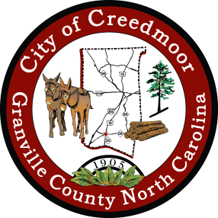

LEGAL NOTICE
CITY OF CREEDMOOR
REGULAR MEETING

The City of Creedmoor BOC Regular meeting
is scheduled to be held on October 2, 2023 at 6 p.m. in the
Boardroom at City Hall, 111 Masonic Street, Creedmoor, NC.
Please take notice that the Board will gather in the Mayor’s office immediately before the meeting to share a light meal. No City business will be discussed.

*Any comments or questions should be directed to Barbara Rouse, City Clerk at: brouse@cityofcreedmoor.org

