MAYOR
Robert V. Wheeler
CITY MANAGER
Michael O. Turner

COMMISSIONERS
Emma Albright
Edward Gleason
Georgana Kicinski
Robert Way
Archer Wilkins

CITY OF CREEDMOOR
P.O. Box 765
111 Masonic Street
Creedmoor, NC 27522
www.cityofcreedmoor.org
(919) 528-3332
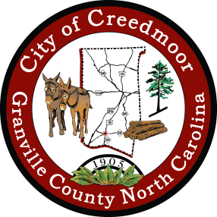

LEGAL NOTICE
CITY OF CREEDMOOR
BOA MEETING –
CANCELED

Meeting Notice

Please take notice that the City of Creedmoor Board of Adjustment meeting scheduled for November 6, 2023 has been canceled due to a scheduling conflict.

*Any questions should be directed to Barbara Rouse, City Clerk to: brouse@cityofcreedmoor.org

