CITY OF CREEDMOOR
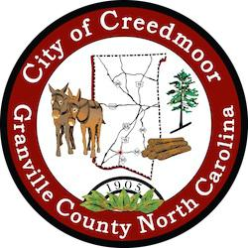

BOARD OF COMMISSIONERS
BOC - WORK SESSION
OCTOBER 16, 2023
6:00 PM

- CALL TO ORDER AND INVOCATION | Commissioner Wilkins

- PLEDGE OF ALLEGIANCE | Commissioner Gleason

- ROLL CALL

- APPROVAL OF AGENDA

- DISCUSSION ITEMS

5.a Wayfinding Signs | Michael S. Frangos AICP, CZO [p. 2]

5.b 2023 Creedmoor Music Festival Summary | Christopher Horrigan [p. 23]

5.c Creedmoor Veterans Memorial Final Site Selection | Commissioner Wilkins [p. 35]

5.d Permanent Public Parking Access Easement Agreement | Kevin Hornik [p. 43]

5.e ETJ and Annexation Agreements | Kevin Hornik [p. 49]

- ADJOURNMENT

1

