CITY OF CREEDMOOR
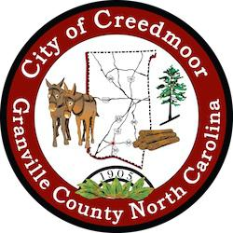
BOARD OF COMMISSIONERS
BOC - REGULAR SESSION
APRIL 2, 2024
6:00 PM

- CALL TO ORDER AND INVOCATION | Commissioner Way

- PLEDGE OF ALLEGIANCE | Commissioner Albright

- ROLL CALL

- APPROVAL OF AGENDA

- CONSENT AGENDA

5.a CAMPO Memorandum of Understanding | Michael Frangos

5.b | Approval of March 5, 2024 and March 18, 2024 BOC Meeting Minutes | Clerk
5.c | FYE 2024 Financial Auditing Contract | Lee Faines

- INTRODUCTIONS, RECOGNITIONS AND PRESENTATIONS

6.a Presentation of Proclamation to Mildred Goss | Mayor Wheeler

- REQUEST TO ADDRESS THE BOARD

- PUBLIC COMMENT

- OLD BUSINESS

9.a Discussion on Petition to General Assembly about City Boundaries | City Manager

- NEW BUSINESS

10.a The Brough Law Firm MOU for FY24 | City Manager

- DISCUSSION ITEMS

11.a MPT Kicinski requested Board discussion on closing Sanderford Street every Saturday for the operation of a Creedmoor Farmer’s Market | Mayor Pro Tem

- CITY MANAGER'S REPORT 12.a Managers Reports
- SGWASA REPORT

1

- COMMISSIONER REPORTS

- MAYOR'S REPORT

- CLOSED SESSION

- ADJOURNMENT

2

