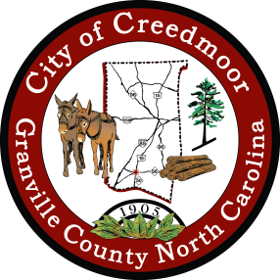

CITY OF CREEDMOOR
P.O. Box 765
111 Masonic Street
Creedmoor, NC 27522
www.cityofcreedmoor.org
(919) 528-3332

MAYOR
Robert V. Wheeler

CITY MANAGER
Michael O. Turner

COMMISSIONERS
Emma Albright
Edward Gleason
Georgana Kicinski
Robert Way
Archer Wilkins

Proclamation
Honoring Ms. Mildred Currin Goss

Whereas: Ms. Mildred Currin Goss was born in Sassafras Fork Township to Roger & Cora Currin on August 28, 1929, and;

Whereas: Ms. Goss has three children, Sandra Aiken, Karen Kimrey (Clay), and Jerry Goss, and two grandchildren, Tracy McLendon and Genie Parish (Chad), and;

Whereas: Ms. Goss worked for the State of North Carolina for 39 ½ years and retired in February of 1996 as a Health Information Manager with ADATC (Alcohol & Drug Abuse Treatment Center), and;

Whereas: Ms. Goss organized the Granville County Genealogy Society and has been the president for the past 30 years has been doing lineage research for multiple groups since the early 1990’s, and;

Whereas: Ms. Goss has been a member of the United Daughters of the Confederacy (UDC) since 1995, and is currently serving as the NC division Registrar and is a member of the Daughters of the American Revolution (DAR) and organized the chapter in Granville County in 2000, and;

Whereas: Ms. Goss worked with the Board of Elections for 20 years as a Precinct Judge at Creedmoor Elementary School, served on the Granville County Library Board, and served on the City’s Planning Board from 2001 until 2018, and;

Whereas: Ms. Goss has researched, cataloged, and collaborated on cemetery records for Granville County, 454 cemeteries which included endless days walking in the woods looking for old cemeteries, and has published three books, Currin Connection, Bible Records of Granville County, and Marriage Records of Granville County 1866 – 1894.

Now Therefore: Be it proclaimed that as the Mayor, and on behalf of the City of Creedmoor, I thank
Ms. Mildred Currin Goss, for her public service to the City of Creedmoor and the
community, and her tireless dedication to the preservation of the records of Granville County.

_______________________________
Robert V. Wheeler, Mayor

