CITY OF CREEDMOOR
P.O. Box 765
111 Masonic Street
Creedmoor, NC 27522
www.cityofcreedmoor.org
(919) 528-3332
MAYOR
Robert V. Wheeler
CITY MANAGER
Michael O. Turner

COMMISSIONERS
Emma Albright
Edward Gleason
Georgana Kicinski
Robert Way
Archer Wilkins

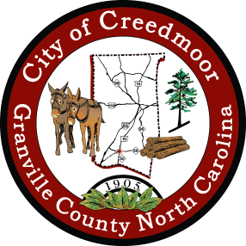

PROCLAMATION
Public Works Week, May 19th – 24th, 2024

WHEREAS, public works infrastructure, facilities, and services are of vital importance to sustainable communities and the health, safety, and well-being of the people of the City of Creedmoor, North Carolina; and,

WHEREAS, these infrastructure, facilities, and services could not be provided without the dedicated efforts of public works professionals, engineers, managers, and employees from State and Local Government and the private sector, who are responsible for and who plan, design, build, operate, and maintain the transportation, water supply, water treatment, public buildings, structures, and facilities, and who deliver solid waste services, transit, and fleet services which are essential to serve our citizens; and,

WHEREAS, it is in the public interest for the citizens, civic leaders, and children in the City of Creedmoor to gain knowledge of and to maintain an interest and understanding of the importance of public works and public works programs in their respective communities; and,

WHEREAS, the year 2024 marks the 64th annual National Public Works Week sponsored by the American Public Works Association be it now,

RESOLVED, I, Robert Wheeler, Mayor of the City of Creedmoor, do hereby proclaim May 19-25, 2024 as National Public Works Week. I urge all citizens to join with representatives of the American Public Works Association and government agencies in activities, events, and ceremonies designed to pay tribute to our public works professionals, engineers, managers, and employees and to recognize the substantial contributions they make to protecting our national health, safety, and advancing quality of life for all.

IN TESTIMONY WHEREOF, I have hereunto set my hand and caused to be affixed the seal of the City of Creedmoor this 7th day of May 2024.

Robert V. Wheeler, Mayor

Barbara Rouse, City Clerk

